**Plotting with RStudio**



**Objective of Exercise:**

This lab introduces you to plotting in R with ggplot and GGally. GGally is an extension of ggplot2.

**Exercise:**

1. Click the plus symbol on the top left and click R Script to create a new R script, if you don’t have one open already.

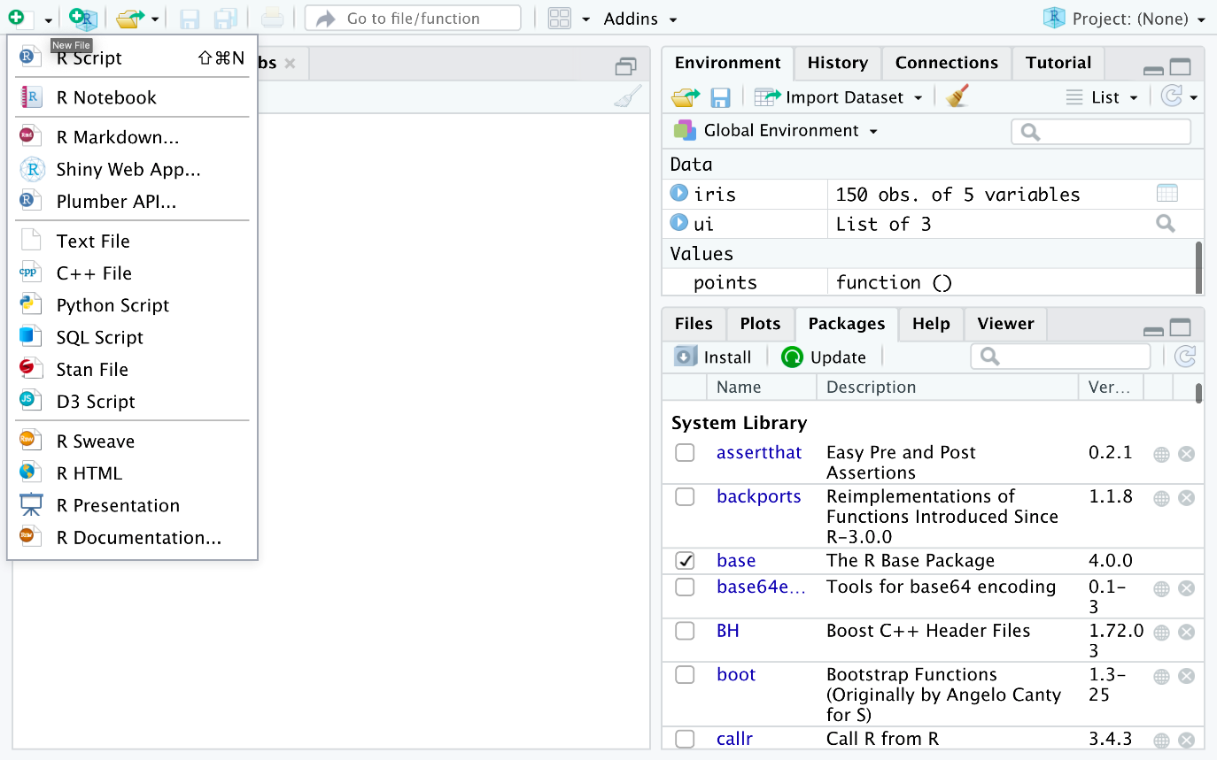

1. You will use the iris dataset. If you don’t have it loaded, copy and paste the following into your R script file.
2. 1
3. 2
4. library(datasets)
5. data(iris)

Copied!

1. In the previous lab, you installed the libraries necessary to create plots, let’s execute the following commands:
2. 1
3. 2
4. library(GGally)
5. ggpairs(iris, mapping=ggplot2::aes(colour = Species))

Copied!

1. Select the commands and click Run on the top. You’ll see the following plot in the **Plots** window:

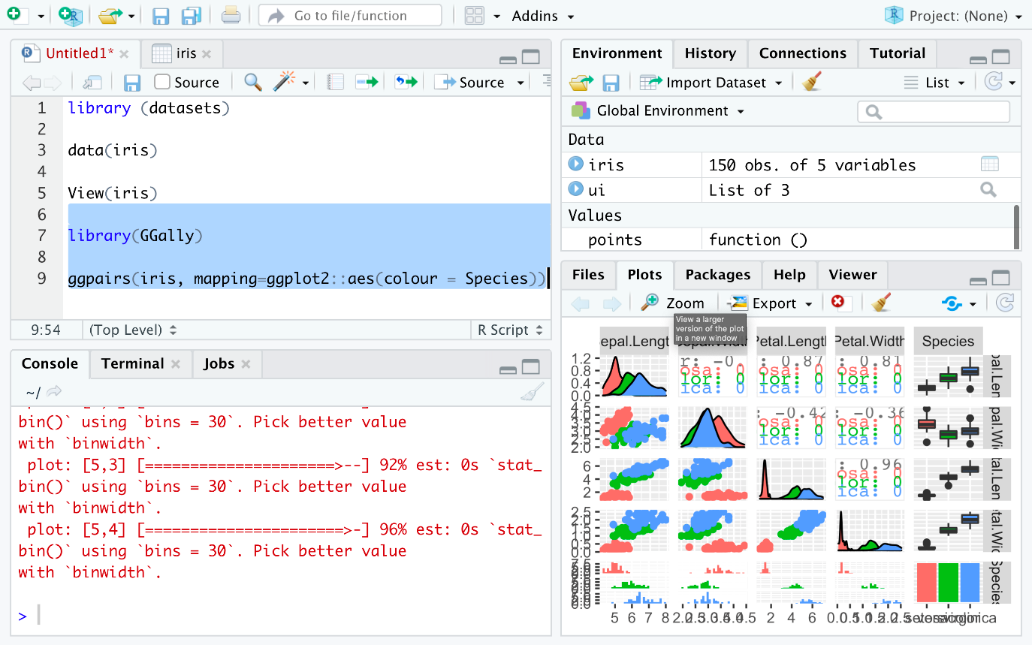

1. Click the **Zoom** icon on the plot window to zoom and see the plot.

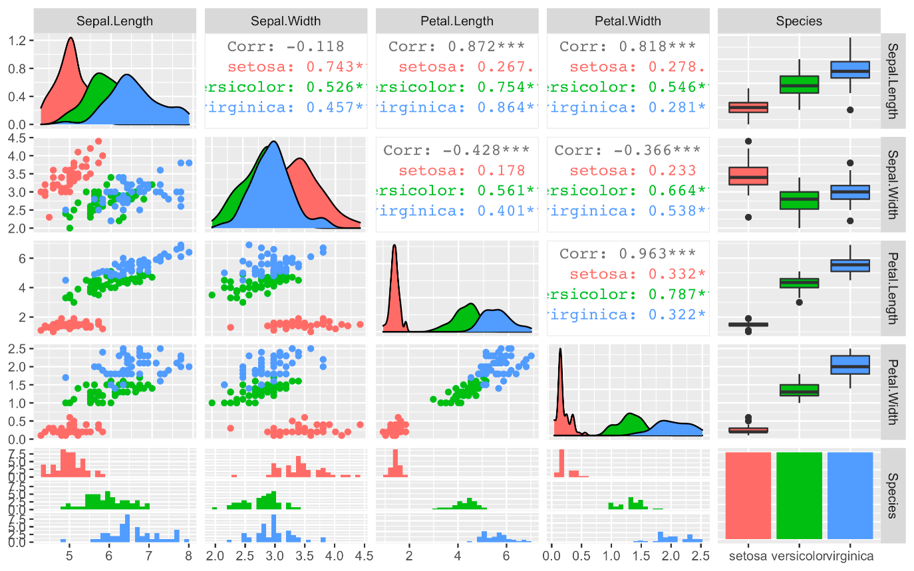

1. This gives you a lot of information for a single line of code. First, you can see the data distributions per column and species on the diagonal. Then you see all the pair-wise scatter plots on the tiles left to the diagonal, again segregated by color. It is, for example, obvious that a line can be drawn to separate **setosa** against **versicolor** and **virginica**. In later courses, you will also learn how the overlapping species can be separated. This is called supervised machine learning using non-linear classifiers. You can also see the correlation between individual columns in the tiles on the right to the diagonal, which confirms that **setose** is more different, hence easier to distinguish, than **versicolor** and **virginica**. A correlation value close to one signifies high similarity, whereas a value closer to zero signifies less similarity. The remaining plots on the right are called **box-plots**, and the ones at the bottom are called **histograms**, but you will learn about this in a more advanced course in this series.

**Author(s)**

**Romeo**

**Other Contributor(s)**

**Lavanya**

**Change log**

| **Date** | **Version** | **Changed by** | **Change Description** |
| --- | --- | --- | --- |
| 2022-12-30 | 1.2 | Steve Hord | QA pass edits |
| 2020-12-10 | 1.1 | Aije | Created simplified version of the lab |
| 2020-12-10 | 1.0 | Malika Singla | Migrated lab to Markdown |

**© IBM Corporation 2020. All rights reserved.**